- Object abb hum khud nii banayenge , IOC ya ni ki spring dega. Wo apne paas store karke rakhega.IOC container ek baxa hai wo jama rakhta hai and hume deta jai jab hum mangenge.
Application context is a way to achieve IOC container. Dono ek hi baat ahi.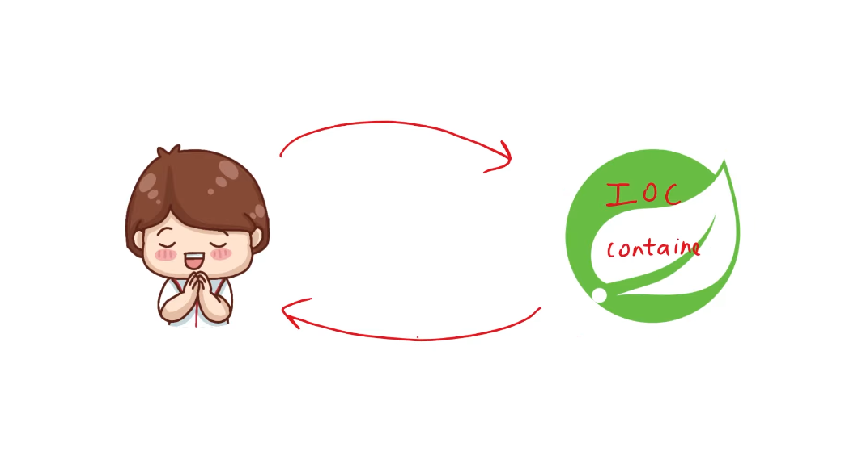
- @Component annotation hai kisi class k upar toh wo class IOC container store karke rakhega.
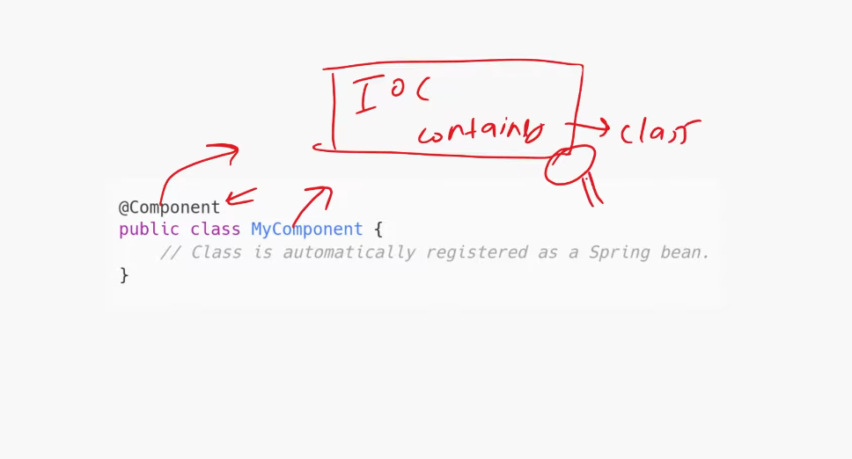
Bean -> is nothing but object.
Kisi bhi class k upar @Component likh do wo bean ban jaati hai and IOC container package scan karti hai and jiske upar component likha hota hai yani ki beans hote hai wo apne mei store kar leti hai and apne ko jab chahiye rehti hai wo leke de deta hai.

- @SpringBootApplication ye annotation main class mei lagate hai and ek hi hota hai.
Kaam kya karti hai ->
>@Configuration
>@EnableAutoConfiguration
>@ComponentScan
Ye teeno kaam wo karti hai .
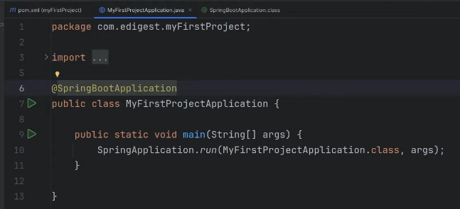
- So here you can see com.edigest.myfirstproject package , so here in this package this beans scan and all under this @springBootApplication works. So if you create another package outside this, then this @ springBootApplication won’t work , component scan nii hoga.
- @Autowired -> spring mujhe object dedo. Basically DEPENDENCY INJECTION.

- Simple Controllers functions:

